**Task 1**

1.

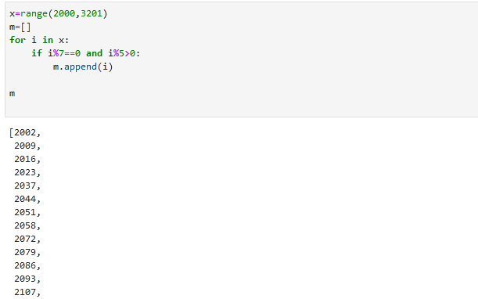

2.

x=range(2000,3201)

m=[]

for i in x:

if i%7==0 and i%5>0:

m.append(i)

m

3.

fn= input("input first name")

ln=input("input last name")

name=fn+" "+ln

name[::-1]

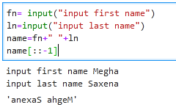

4.

diameter=12

r=diameter/2

v=4/3*3.14*r**3

print(v)

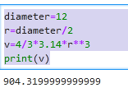

**Task 2:**

1.

a=input("enter comma seperated number")

m=[]

for i in a:

if i !=",":

b=int(i)

m.append(b)

m

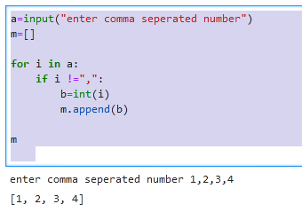

2.

l= 5

for i in range(1, l+1):

for m in range(1, i+1):

print("*", end=' ')

print("")

for i in range(l,0,-1):

for m in range(i-1,0,-1):

print("*", end=' ')

print("")

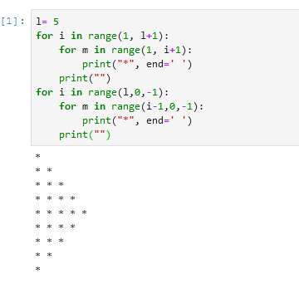

3.

a= input("input a word")

a[::-1]

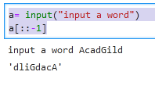

4.

a='''WE, THE PEOPLE OF INDIA,\n having solemnly resolved to constitute India into a

SOVEREIGN,\n SOCIALIST, SECULAR, DEMOCRATIC REPUBLIC\n and to secure to all

its citizens'''

print(a)

